 | TT Rock Stars | Maths  Oak Academy | English  Oak Academy | Wider Curriculum  Oak Academy | Study Ladder  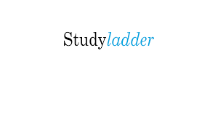 | Spellings  Reading  Projects
Monday | TTRockstars | Partitioning | Sentence revision | PSHE | Studyladder | Please recap the spellings from last half term
Tuesday | TTRockstars | Order and compare | Sentence revision | PSHE | Studyladder | Please recap the spellings from last half term
Wednesday | TTRockstars | + and - 3 digit and 1 digit numbers | Sentence revision | PSHE | Studyladder | Please recap the spellings from last half term
Thursday | TTRockstars | + and - 3 digit numbers and tens | Sentence revision | PSHE | Studyladder | Please recap the spellings from last half term
Friday | TTRockstars | + and - 3 digit numbers and hundreds | Sentence revision | PSHE | Studyladder | Please recap the spellings from last half term

